**AIT91001 CI & ML Assessment 1 Remarks**

Last Name: First Name:

Student ID:

**Remarks:**

My solution:

$$y= θ_{0}+ θ_{1}x_{1}+θ_{2}x_{2}+θ_{3}x_{1}x_{2}$$

First, I have just used the simple linear regression which leads to the equation like:

$$y= θ_{0}+ θ_{1}x_{1}+θ_{2}x_{2}$$

Where,

$y$ = Electron Velocity

$x_{1}$ = Voltage

$x_{2}$ = External Force

But the accuracy of the linear regression is very low. I have used MSE to find out the error as well I have used the graph to visualize to find out that whether my method is suitable or not.

Method 1 Image:

The MSE error of that first approach is very high. The MSE value was 51.5502975. So obviously that method is not sufficient to fit the data. Even in a graph also we can see that data is not fitted properly with this equation.

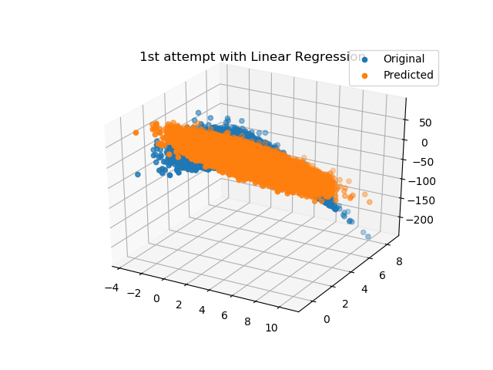

Figure 1: Graph to show the Original as well as Predicted value to get good insight into the data and fitting of the data. This data is predicted with the linear regression method.

Then from data, it seems that is we can go to the second order polynomial then we can have more accuracy. So, I have changed the function by:

$$y= θ_{0}+ θ_{1}x_{1}+θ_{2}x_{2}+θ_{3}x_{1}x_{2}$$

When I have used this method at that time, I found that the MSE is reduced to very low value. The MSE for this method is 3.9826091. Figure 2 show the graph for the original and predicted values for the data.

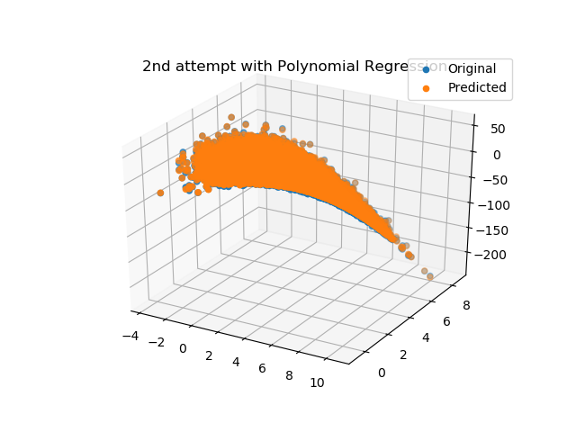

Figure 2. This is the graph for the polynomial regression for dataset.

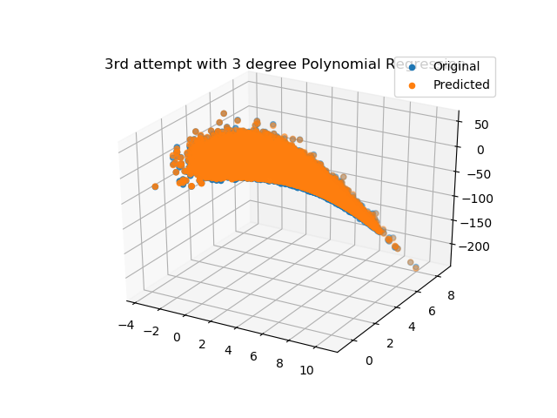

Figure 3. This is the graph for the polynomial regression with more higher order polynomial for dataset.

Figure 2 shows that this method fits the data very well. But to increase the accuracy further, I have tried another additional polynomial.

So, in third method, I have used equation,

$$y= θ_{0}+ θ_{1}x_{1}+θ_{2}x_{2}+θ_{3}x_{1}x_{2}+θ_{4}x_{1}x_{2}^{3}$$

But the improvement in the MSE is very less. MSE value is 3.982481. So, the improvement in this method is about ${10}^{-5}$. Figure 3 show the predict value for the original dataset using third method.

So, I have finally decided to use

$$y= θ_{0}+ θ_{1}x_{1}+θ_{2}x_{2}+θ_{3}x_{1}x_{2}$$

Because it has good accuracy with less coefficient. Less coefficient means less computation as well as the less storage space.